Before doing CPR
Before doing CPR...
(Cardiopulmonary Resuscitation)
- Are your surroundings safe?
- Is the person conscious or unconscious?
- If they appear unconscious tap or shake their shoulder and
ask “Are you Okay?”
- If the person doesn't respond and two people are available,
have one person call 911 or the local emergency number and get the AED, if one is available, and have the other person begin CPR.
- If you are alone and have immediate access to a telephone,
call 911 or your local emergency number before beginning CPR. Get the AED, if one is available.
6. As soon as an AED is available, deliver one shock if instructed by the device, then begin CPR.
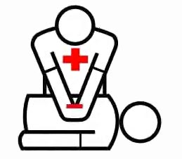
RememberCAB!
C=Compressions
A= Airway
B= Breathing

