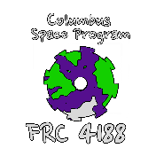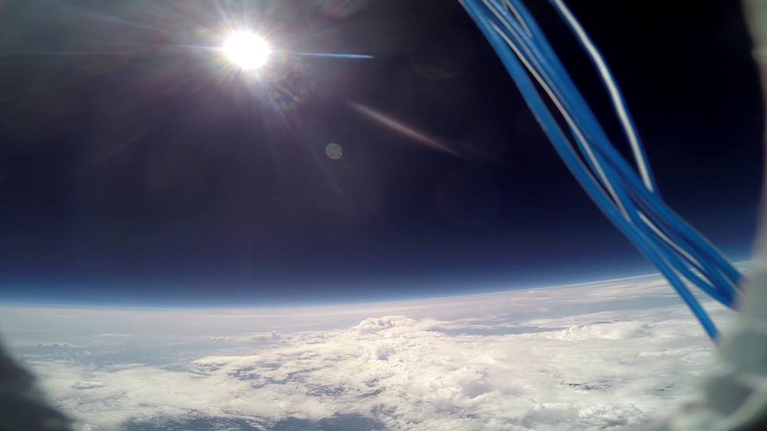

Columbus Space Program

**TECH IT OUT CHALLENGE**

Since 2016:

3000 Students

100 Teachers

55 Schools

**SOCIAL MEDIA GROWTH HIGHLIGHTS**

Twitter – 82.11% Growth Annually; (May 2017) 1122 New Followers

Facebook – 43.02% Growth Annually

Instagram – 42.7% Growth Annually

**SPONSORSHIP MAKEUP**

2012: 16.7% Local

2020: 85% Local

2022: 47% Local

**AMAZING COLUMBUS**

Video promoting Columbus as a city

CSP invited for 45 second appearance spotlighting technology; included Aerostat

***FIRST* in the Valley** Finances Over 5 Years

$359,900 to *FIRST*

$675,650 Impact

The **Tech It Out** challenge has directly impacted the growth of *FIRST* in the Valley area. With a 200% growth, and 31% retention, the impact to both CSP and students was growing at high rate prior to the pandemic. We are restarting with 2022.

**Shadowing, Pre-Service**: We have identified several problems with getting *FIRST* spread in the Columbus region by interviewing teachers and potential mentors. One of the main issues is the lack of confidence that teachers and mentors have in their own abilities. Since our head coach is a teacher himself, he has helped us to understand what teachers need: Training. We used the methods we’ve perfected with spreading DREAMS addressing the needs of teachers to manage FLL teams. One school supported in 2018 and two schools supported in 2019 for Shadowing, and 30 pre-service teachers supported at CSU.

**Team MakeUp 2022:**

28 Students (35.6% Female) – Male/Female Captains

54% Students Started in FLL, and 93% Students Joined FTC Before CSP

History:

2012: 19 Students (52.6% Female) – Female Captain

2013: 17 Students (23.5% Female) – Male Captain

2014: 12 Students (58.3% Female) – Male Captain

2015: 14 Students (64.3% Female) – Female Captain

2016: 25 Students (32% Female) – Male Captain

2017; 22 Students (45% Female) – No Captain

2018: 33 Students (33.3% Female) – Female Captain

2019: 39 Students (24.4% Female) – Female Captains

2020: 48 Students (33.5% Female) – Male Captains

2021: 27 Students (37.0% Female) – Male Captain

**Alliance Memberships:**

Compass Alliance/Manufacturing Hub – belly pans, powder coating

*FIRST* Alliance – 5S, DREAMS, Tournament Support

*FIRST* Like a Girl – BBG, alumni spotlight (two in development) –one of 17 ambassador teams in the world

Information Technology Solutions

**DREAMS: 2007 – 2022**

32 Launches

130+ Experiments

Eclipse to the Edge of Space – 15 students, NASA partial funding, Path of Totality, 5 experiments

2018 - 2019: three launches, one with GHP, Aflac Duck and Wilber (FRC1902) plush launched, six FLL experiments flown, 10 FRC teams flown

**CSP By the Numbers**