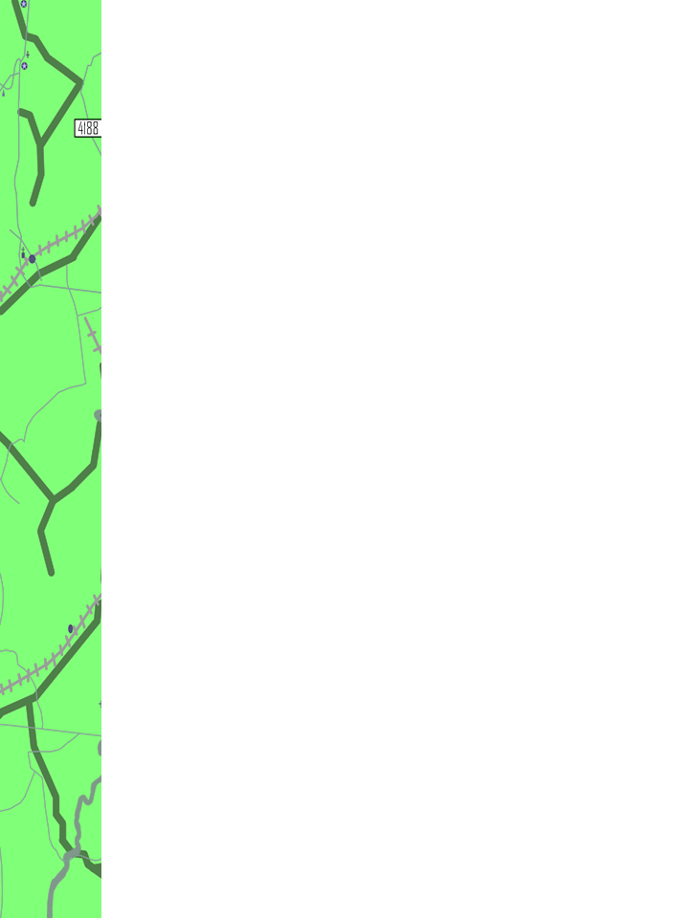

**Tech It Out 2022**

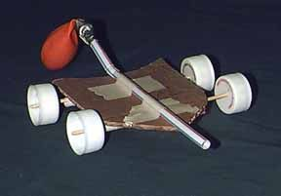

**Planetary Rover Activity**

**Supplies:**

masking tape

plastic bottle caps

straws

balloons

cardboard

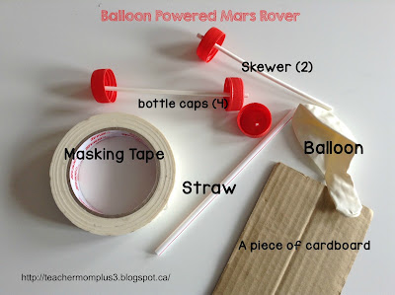

1. – Skewer bottle caps to make two two-wheeled axels
2. Use Masking Tape to place the skewers as wheels
3. Using Masking Tape, tape the straw to the top of the rover
4. Place the balloon at the mouth of the straw (use a rubber band to secure if needed)
5. Blow up the balloon and place the Rover on the table to move across the ground

Activities for Students

In 2016 as Georgia FIRST moved from the regional model to districts, Columbus welcomed teams for the first time. As part of that experience, CSP saw an opportunity to share robotics with the students from around the area. However, our coach is a teacher by day and he recognized that our Robotics in the Classroom activities that we shared with schools we visited would be repeatable for the field trip. In the four years since transitioning, 3000 students and 100 teachers have been introduced to competition and this activity is a part.

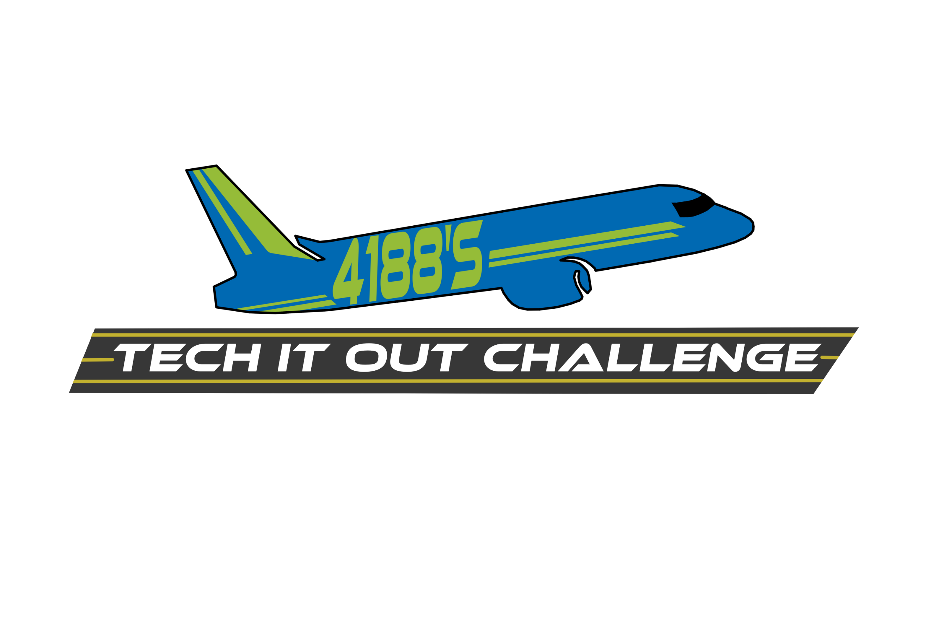

x